**Interactive Report with AT USER-COMMAND**

***Program theme:*** *In this simple demo program you will get how to work interactive report with AT USER-COMMAND and MENU PAINTER.*

**Step # 1:** Go to SE38 transaction code, create an include program.

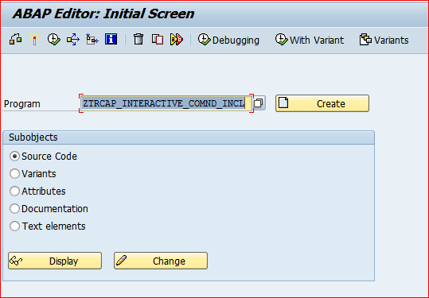

**Step # 2:** Provide the title and select an include program type and click on save button.

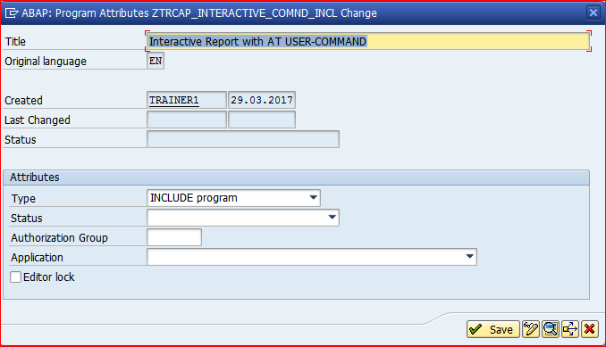

**Step # 3:** Save it in the package.

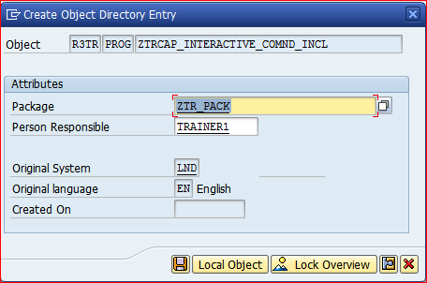

**Step # 4:** Write an include program code logic.

*\*&---------------------------------------------------------------------\**  
*\*&  Include  ZTRCAP_INTERACTIVE_COMND_INCL*  
*\*&---------------------------------------------------------------------\**

TYPES : BEGIN OF TY_TAB,  *" LOCAL STRS  " MARA*  
          MATNR TYPE MATNR , *" Material Number*  
          MBRSH TYPE MBRSH, *" Industry sector*  
          MTART TYPE MTART, *" Material Group*  
          MEINS TYPE MEINS, *" Base Unit of Measure*  
        END OF TY_TAB.  
  
DATA :IT_TAB TYPE STANDARD TABLE OF TY_TAB, *"  ITAB*  
      WA_TAB TYPE TY_TAB.  *" WORKAREA*  
  
DATA LV_MATNR TYPE MATNR.

**Step # 5:** Go to SE38 transaction code and create an executable program.

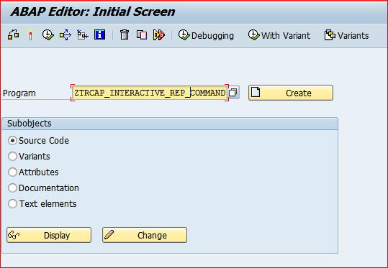

**Step # 6:** Provide the title and select an Executable program type and click on save button.

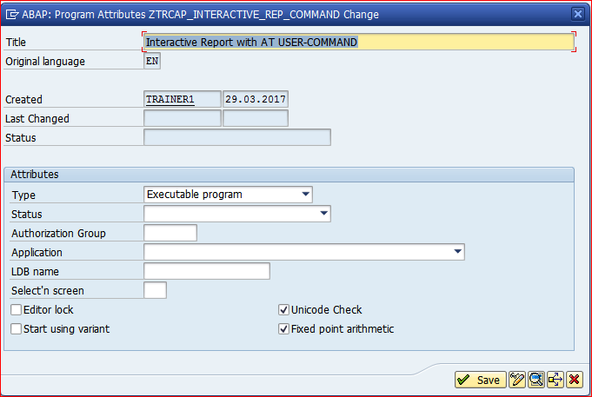

**Step # 7:** Save it in the package.

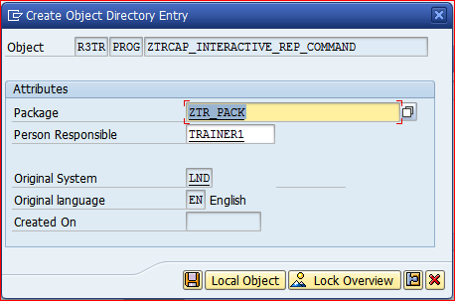

**Step # 8:** Call the Include program and write the executable program code logic.

*\*&---------------------------------------------------------------------\**  
*\*& Report ZTRCAP_INTERACTIVE_REP_COMMAND*  
*\*&---------------------------------------------------------------------\**  
*\*&*  
*\*&---------------------------------------------------------------------\**  
REPORT ZTRCAP_INTERACTIVE_REP_COMMAND NO STANDARD PAGE HEADING LINE-SIZE 250 MESSAGE-ID ZTR_MSG1.  
INCLUDE ZTRCAP_INTERACTIVE_COMND_INCL.  
  
SELECT-OPTIONS S_MATNR FOR LV_MATNR.  
  
START-OF-SELECTION.  
  
SET PF-STATUS 'ZTR_PFS1'. “SE41 Menu Painter Name.  
  
PERFORM  GET_DATA.  
  
END-OF-SELECTION.  
  
  WRITE: 1 'TABINDEX',  
           13 'MATERIAL NO',  
           30 'IND SECTOR',  
           45 'MAT TYPE',  
           55 'BASE UOM '.  
  ULINE.  
  PERFORM  GET_DISPLAY.  
  
AT USER-COMMAND.  
  
  CASE SY-UCOMM.  
  
    WHEN 'DISP'.  
  
      WRITE : 'USER NAME:' , SY-UNAME , 'DATE:', SY-DATUM , 'TIME:' , SY-UZEIT.  
  
    WHEN 'TCODE'.  
  
      CALL TRANSACTION 'SE11'.  
  
    WHEN 'INFO'.  
  
      WRITE 'CALLING INTERACTIVE REPORT WITH AT USER-COMMAND '.  
  
    WHEN 'MENU1'.  
  
      WRITE 'FIRST MENU IS TRIGGERD'.  
  
  ENDCASE.  
*\*&---------------------------------------------------------------------\**  
*\*&      Form  GET_DATA*  
*\*&---------------------------------------------------------------------\**  
*\*       text*  
*\*----------------------------------------------------------------------\**  
*\*  -->  p1        text*  
*\*  <--  p2        text*  
*\*----------------------------------------------------------------------\**  
FORM GET_DATA.  
  
  SELECT MATNR  
          MBRSH  
          MTART  
          MEINS  
     FROM MARA  
     INTO TABLE IT_TAB  
     WHERE MATNR IN S_MATNR.  
  
  IF SY-SUBRC EQ 0.  
    WRITE : 'RECORDS FOUND IN MARA TABLE:' , SY-DBCNT.  
  ENDIF.  
  
  WRITE:  'MAT NO',  
          20 'IND SECTOR',  
          22 'MAT TYPE',  
          27 'BASE '.  
ENDFORM.  
*\*&---------------------------------------------------------------------\**  
*\*&      Form  GET_DISPLAY*  
*\*&---------------------------------------------------------------------\**  
*\*       text*  
*\*----------------------------------------------------------------------\**  
*\*  -->  p1        text*  
*\*  <--  p2        text*  
*\*----------------------------------------------------------------------\**  
FORM GET_DISPLAY .  
  
  LOOP AT IT_TAB INTO WA_TAB.  
    WRITE : / SY-TABIX,  
              WA_TAB-MATNR,  
              WA_TAB-MBRSH,  
              WA_TAB-MTART,  
              WA_TAB-MEINS.  
  ENDLOOP.  
ENDFORM.

**Step # 9:** Go to SE41 transaction code and design the menu painter as per the requirement, save and activate and attach the same in the report by using the SET PF-STATUS.

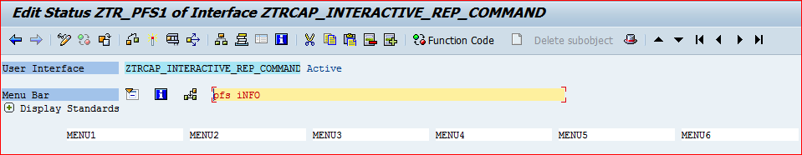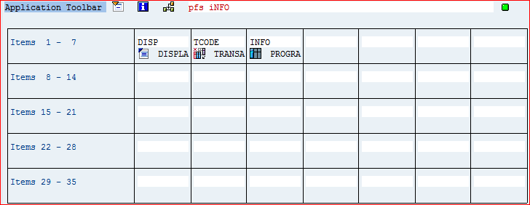

**Step # 10:** Save and activate the program and execute it (F8).

Provide the material number range in selection screen and execute it.

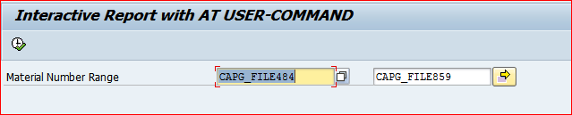

**Step # 11:** list displayed with the range of materials based on the selection screen inputs.

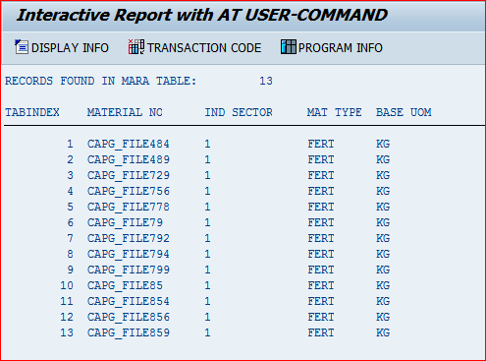

**Step # 12:** When you click on at user command DISPLAY INFO button on the output list, find the below screen output.

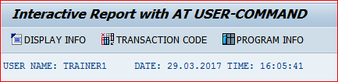

**Step # 13:** When you click on at user command TRANSACTION CODE button on the output list it will call the ABAP Dictionary Initial Screen.

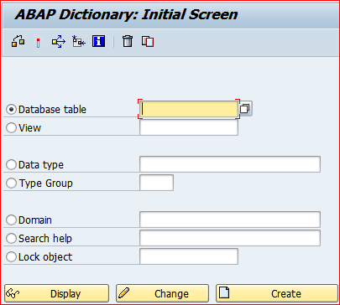

**Step # 14:** When you click on at user command PROGRAM INFO button on the output list, display any message or report output presented in the below screen.

